

|  |
| --- |
| **ASSIGNMENT TOP SHEET**  **Faculty of Creative Arts, Technologies & Science**  **Department of Computing & Information Systems** |

|  |  |
| --- | --- |
| **Student Number:** | Unit Code  CIS016-2 (**Assignement 1**) |

|  |  |  |
| --- | --- | --- |
| Unit Name  Object-Oriented Programming and Software Engineering |  | Deadline for Submission(s)  **14:00PM 16th Nov 2017** |

|  |  |  |
| --- | --- | --- |
| Student's Surname |  | Student's Forename |

|  |
| --- |
| Unit Coordinator: **Dr. Renxi Qiu** |

|  |
| --- |
| Assignment Details:  **Assignment 1: Control an Elevator - A C# Project** |

**Instructions to Student:**

Work presented in an assessment must be your own. Plagiarism is where a student copies work from another source, published or unpublished (including the work of another student) and fails to acknowledge the influence of another’s work or to attribute quotes to the author. Plagiarism is an academic offence and the penalty can be serious. The University’s policies relating to Plagiarism can be found in the University regulations. To detect possible plagiarism we may submit your work to the national plagiarism detection facility. This searches the Internet and an extensive database of reference material including other students’ work to identify. Once your work has been submitted to the detection service it will be stored electronically in a database and compared against work submitted from this and other universities. It will therefore be necessary to take electronic copies of your materials for transmission, storage and comparison purposes and for the operational back-up process. This material will be stored in this manner indefinitely.

**I have read the above information and I confirm that this work is my own and that it may be processed and stored in the manner described.**

**Signature (Print Name): ........................................................... Date: ...................................**

Extension deadline

Mitigation team agrees that the assignment may be submitted ____ days after the deadline and should be marked without penalty.

Mitigation team confirmation...................................................................................................................

Please leave sufficient time to meet this deadline and do not leave the handing-in of assignments to the last minute. You need to allow time for any system problems or other issues

ASSIGNMENT ONE:

CONTROL AN ELEVATOR – A C# PROJECT

# Aim

This assignment aims to develop students’ capabilities and skills of solving real-world problems with C# programming language.

# Task description:



The simple version of the elevator is illustrated below:

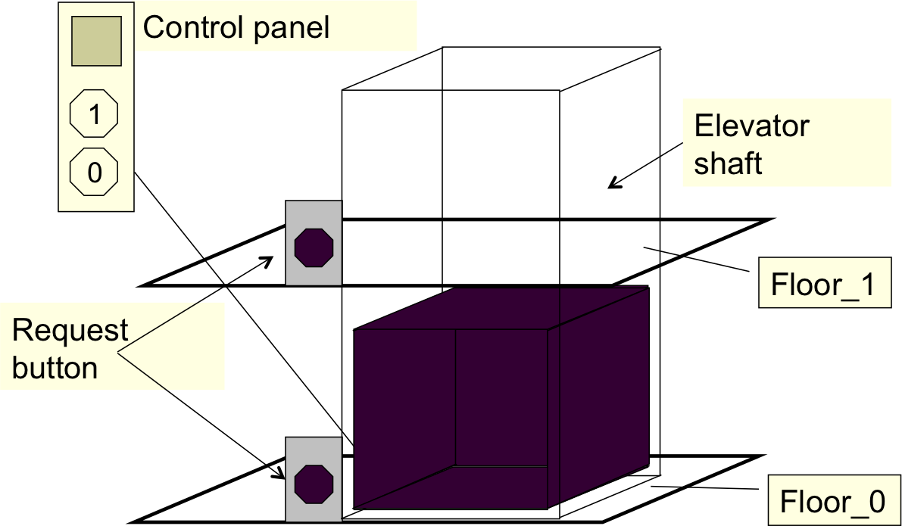

Task 1: To create a GUI which contains

* Two request buttons corresponding to the two floors, respectively
* One control panel with two buttons and a display window
* Two display areas that display the status of the elevator, i.e. which floor the elevator currently stays, one is of each floor
* A log button

Task 2: To create a control program that processes the events published by the GUI. That is,

* When any request button is pressed,
  + the elevator moves to the corresponding floor
  + then the display areas and the display window on the control panel show the corresponding floor number at the same time
* When the floor number buttons on the control panel are pressed,
  + the elevator moves to the corresponding floor
  + then the display areas and the display window on the control panel show the corresponding floor number at the same time

Task 3: To implement a program to animate the events described in Task 2

Task 4: To create a log which record all operations and the corresponding status of the elevator and the time information in a MS Access database

Task 5: To show the log on GUI

Task 6: To integrate the programs developed in Tasks 1 to 5

Task 7: To write a report which should have the following sections: aim, task description, design, programs and comments, and testing results.

# Submission:

What to submit – ***Report*** and ***The Entire C# Project Code***

**Report**:

Name your submission – Your submission should be named with the following format: studentIDAssignmentOneReport.doc

Where to submit –Under the assignment 1 folder within the Assessment menu of this Unit’s BREO site, called “Assignment One – Report”

***The Entire C# Project Code:***

The entire C# project including all folders and files, and the DB which should be saved in bin->debug folder, and saved as .zip file

Name your submission – Your submission should be named with the following format: studentIDAssignmentOne.zip

Where to submit – Under the assignment 1 folder in the Assessment menu of this Unit’s BREO site, called “Assignment One C# Project Code Here”

**Deadline for submission** – By 14:00PM 16 Nov 2017

# Important note:

This is practical based mini-project assignment. Both C# Project Code and Report are required and will be marked. Discussion and peer help are encouraged but copying peers’ work is regarded as plagiarism.

**The Marking Scheme is in the next page.**

**CIS016-2 Assignment One - Marking Scheme:**

|  |  |  |  |  |  |
| --- | --- | --- | --- | --- | --- |
|  | | | **Tasks 1 to 6 (70%)** | | **Task 7 (30%)** |
| **FAIL** | G | 0 | Not submitted | | Not submitted |
| F | 25-34 | Task 1 | Major Syntax errors, cannot be compiled. |  |
| E | 35-39 | Task 1 | No major syntax errors, but incomplete GUI | Incomplete report |
| **PASS** | D | 40-43 | Task 1 | Complete GUI for Task 1 | Basic report with program and some testing results |
| 44-46 | GUI and event handlers in place for all buttons |
| 47-49 | Task 1 full functions with no syntax error |
| C | 50-53 | In addition to task 1 completed | Task 2 event handlers are well designed | Code and testing results are explained to certain extends |
| 54-56 | Task 2 &3 event handlers are well designed |
| 57-59 | Task 2&3 work properly |
| B | 60-63 | In addition to  task 1 ,2 and 3 completed | DB is designed and implemented | Code and testing results are clearly and thoroughly explained |
| 64-66 | When the log button is pressed, log information is sent to and stored in the DB |
| 67-69 | Log information displayed on GUI and the DB function specified above |
| A | 70-74 | In addition to  task 1-5 completed | Integrated program | Well-structured report and written in formal English language |
| 75-79 | Integrated program& the status of the elevator is graphically displayed |
| 80-100 | Well-structured and neatly written code |